Pot Prayer for No Headaches in Cars, Trains and Walks
Share
Retweet
Syndicate
Views (39)
Aug. 4, 2015 7:20 pm
Categories: None
Keywords: pot, federal politician, cm, Breason, upset
1. Pray for a pot to prevent a headache each day.
2. Whenever there is an upset, mentally "stay" the pot from being removed for money by a federal politician.
3. Breason out 250 breasonings of the apple (5 apples=1*1*1, 2*2*2, 3*3*3, 4*4*4, 5*5*5 cm) to keep the pot protecting individuals.
4. Breason out 5 pots (pot=10*10*10 cm) in 5 seconds to prevent headaches on walks and in cars and trains.
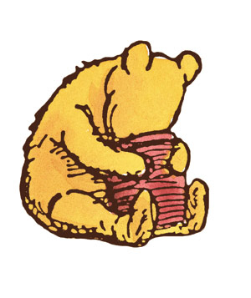
Public Domain
Lining one's ways with honey pots, like that of Winnie the Pooh, prevents upsets, especially in children.

