2015-2016
Finish 16*250 breasonings of Pedagogy, Medicine, Meditation and Economics.

Argument, Number of paragraphs to breason out, Date

Meditation
*keep number needed to breason out from 12/24/15

- God's Infallibility from Being Critiqued - With Correction | 0
- Children/H1/Earning Jobs/Protection in Jobs | 0
- Heads of State | 0
- Lucian Mantra (Pure Form) | 0
- Lucian Mantra (Sun Safety) | 0
- Maharishi Sutra | 0
- Meditation Teacher Sutra | 0
- Moving Appearances | 0
- Purusha | 0
- Upasana Sutra | 0
- Yellow God | 0
- Blue Nature | 0
- Appearances | 0
- Pranayama | 0
- Soma | 0
- Hours Prayer | 0
- Green sutra | 0
- 50 Breasonings Per Second | 0
- Meditation Indicator: Lower Risk of Cancer and Other Diseases In Workers and Broadcasters. | 0
- Meditation Indicator: Decreased Stress. | 0 | 42
- Meditation Indicator: Increased Blood Flow. * | 0 | 42
- Meditation Indicator: Decreased Metabolism. | 0 | 42
- Meditation Indicator: Increased Brain Potential. | 0 | 42
- History/Life Skill x | 0- | 42
- History/Myself-aimedness x | 0- | 42
- Productions
Meditation Indicator- Increased Blood Flow 11 is the last original (not based on comments about individual lines in the 4.5 50 As).

Pedagogy

- Two Uses | 0 | ?
- Future | 0 | ?
- Two Types | 0 | ?
- X | 0
- Y | 0
- Z | 0
- Rebreasoning | ?
- Breathsoning | 0
- Rebreathsoning | 0
- Room | 0
- Part of Room | 0
- Direction | 0
- Time to Prepare | 0
- Time to Do | 0 | 10
- Time to Finish | 0 | 10
- God Algorithm | 0 | ?
- Professor Algorithm | 0
- Pedagogy Indicator: Higher Grades | 0
- Pedagogy Indicator: Fewer Stillbirths. | 0
- Pedagogy Indicator: A Greater Number Of Successful Job Applications | 0

Medicine
Underlined = Essay

X headache, runny nose Lucianic preventative measures, etc.

X = with arg per organ system with function sections

- Meditation Protector Currant Bun – first 11 in notebook
left | done
0 | 42

- Help ensure successful conception and prevent miscarriage.
0 | 42

- Lucianic Pedagogical Medicine - diagnose and treat non-A status of organs.
0 | 42

- 4 glasses of water and exercise 45 minute before breakfast.
0 | 42

- Yoga Surya Namaskar and Yoga Asanas (see below), prevent headaches on train and a bent spine.
0 | 42

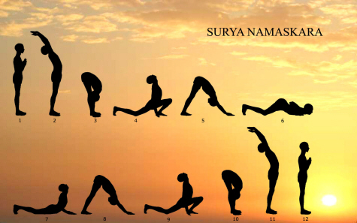
Yoga Surya Namaskar - Practise every morning.
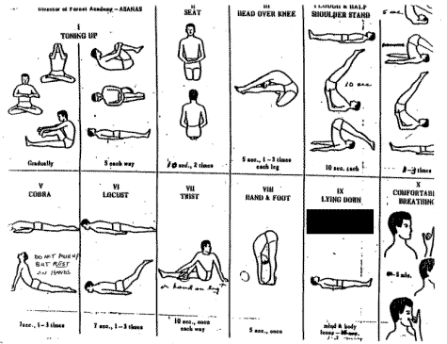
Yoga Asanas - Practise every morning and evening.
- fewer mental breakdowns (schizophrenia)
0 | 42
- and less depression.
0 | 42
* br chapter ideas written up to here *
- Honey Pot Prayer for No Headaches in Cars, Trains and Walks.
0 | 42

- Nut and bolt – headache, education mistake, muscle ache and unwanted effects of excess breasonings, incompatibility of virality with conception, pimple, unwanted thoughts, hallucinogenic appearances, depression prevention.
0 | 42

- Quantum box/prayer – reinforce prevention of problems nut and bolt prevent.
0 | 42

- Head of State Head Ache Prevention - prevent headaches by thinking clearly of head of state.
0 | 42

- Berocca or similar - prevent colds and flu by blocking binding sites of bacteria and viruses.
0 | 42

- Laughter for depression.
0 | 42

- Food - Grains/nuts/fruits/vegetables, sit properly at table during meals.
0 | 42

- /Failure – Pedagogy
0 | 42

- –Pedagogy, Course plan.
0 | 42

- Get in Touch with God about Breasonings Details to see High Quality Imagery and Earn H1.
0 | 42
- Meditation, Panic attack prevented by deep breathing and sutra.
0 | 42
- Go to bed at 9:30 PM.
0 | 42
- 250 breasonings (see Pedagogy and this blog in general) for high quality imagery in writing areas of study (e.g. productions) without discomfort.
42
- Preventing sales from being dangerous - products' philosophy As must be based on a positive argument, have a single argument and be connected in a structure.
42
- Perpetual uni short courses - for best breasoning environment.
42
- Apple meditation for successful relationship.

Not following:
- Brain | 10
- Brain II | 10
- Doctor Sutra | 10
- Heart | 10
- Positive functionalism | 42
- Fend off disease | 42
- Fend off diseased people | 42
- Pinkies (perfect health) | 42
- Hotness to delete mistakes from conclusions | 42
- Psychoanalysis – both Vag characters talk to and listen to each other | 42
- Images are interesting (Vag looks like word image) | 42
- Is the person interested in something? - a psychiatric appearance looking like a radio button not turned on, indicating the appearance is not interesting, so it matters to us and them that it is interesting now. | 42
- “Water” shouldn’t be used in the body | 42
- A child learns from a doctor | 42
- Hermeneutics | 42
- Politics | 42
- Medicine Indicator: Fewer Mental Breakdowns. | 42
- Medicine Indicator: Greater Confidence And Happiness. | 42
- Medicine Indicator: Better Health. | 42

Economics
- also fill with paper notes, Latin, etc
- leave Economics indicators here so algorithm can be about research done into them

- Economics -Breasonings Currency
- Economics -Comparison Between Socialist and Capitalist in Breasonings Currency
- Economics – Socialist (Equal Partner) Parallels with Breasonings Currency
- Economics – Capitalist (Sole Breasoner) Parallels with Breasonings Currency
- Economics – Uses for Money in Theatre Studies
- Economics – Uses for Money in Epistemology
- Economics – Uses for Money in Music
- Economics – Uses for Money in Fine Arts
- Pedagogy Indicator: Higher Grades. Economics Indicator: Housing Prices
- Pedagogy Indicator: Fewer Stillbirths. Economics Indicator: Lower Unemployment
- Pedagogy And Economics Indicator: A Greater Number Of Successful Job Applications
- Medicine Indicator: Fewer Mental Breakdowns. Economics Indicator: Fewer Sick Days
- Medicine Indicator: Greater Confidence And Happiness. Economics Indicator: Fewer Sick Days
- Medicine Indicator: Better Health. Economics Indicator: Fewer Sick Days
- Meditation Indicator: Lower Risk of Cancer and Other Diseases In Workers and Broadcasters. Economics Indicator: Fewer Sick Days
- Meditation Indicator: Decreased Stress. Economics Indicator: Fewer Sick Days.
- Meditation Indicator: Increased Blood Flow. Economics Indicator: Fewer Sick Days
- Meditation Indicator: Decreased Metabolism. Economics Indicator: Fewer Sick Days
- Meditation Indicator: Increased Brain Potential. Economics Indicator: Fewer Sick Days

Next: Popology, Societology (need to study concurrent short courses in Anthropology Sociology)

Essays

Argument, Date

Medicine

- –
- –
- –
- –

Meditation

- –
- –
- –
- –

