Prevent Illness – Free Online Medicine Course
Breason out 80 breasonings * 10 subjects worth of breasonings from Lucianic Medicine to prevent illness (e.g. schizophrenia, depression, where it is recommended that Lucianic Medicine is studied in conjunction with Lucianic Meditation.
Alternative streams of Medicine that can studied by replacing the argument descriptions with the following alternative Medicine descriptions are:
1.Yoga Exercises of Body Systems (Integumentary System, Skeletal System, Nervous System, Cardiovascular System, Endocrine System, Muscular System, Lymphatic System, Respiratory System, Urinary System, Excretory System, Reproductive System, Digestive System and Immune System).
2. Quantum Medicine of Universe Bodies (Universe, Sun, Gravity, Other Celestial Bodies, Respiratory System, God (in fact, Master), Psychiatry, Memory, Abstract Communication (in fact, Computational English) and Eyes.
Index
Meditation
Meditation Protector Currant Bun
Meditation, Panic attack prevented by deep breathing and sutra.
Family Medicine
Help ensure successful conception and prevent miscarriage.
Pedagogy
Lucianic Pedagogical Medicine - diagnose and treat non-A status of organs.
Grades/Failure – Pedagogy, Course plan.
Get in Touch with God about Breasonings Details to see High Quality Imagery and Earn H1.
250 breasonings (see Pedagogy and this blog in general) for high quality imagery in writing areas of study (e.g. productions) without discomfort.
Preventing sales from being dangerous - products' philosophy As must be based on a positive argument, have a single argument and be connected in a structure.
Perpetual uni short courses - for best breasoning environment.
Apple meditation for successful relationship.
Miscellaneous
4 glasses of water and exercise 45 minute before breakfast.
Go to bed at 9:30 PM.
Yoga
Yoga Surya Namaskar and Yoga Asanas (see below), prevent headaches on train and a bent spine.
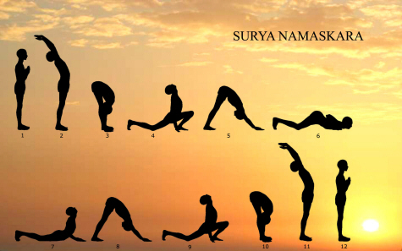
Public Domain
Yoga Surya Namaskar - Practise every morning.
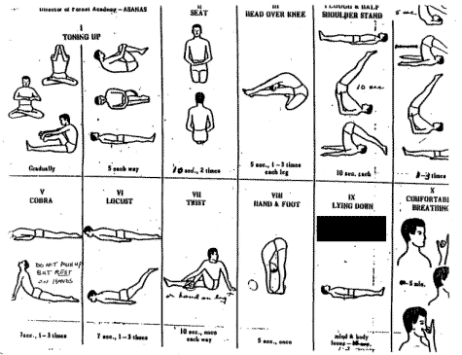
Public Domain
Yoga Asanas - Practise every morning and evening.
Brain
Avoid diseased people, fewer mental breakdowns (schizophrenia) and less depression.
Honey Pot Prayer for No Headaches in Cars, Trains and Walks.
Nut and bolt – headache, education mistake, muscle ache and unwanted effects of excess breasonings, incompatibility of virality with conception, pimple, unwanted thoughts, hallucinogenic appearances, depression prevention.
Quantum box/prayer – reinforce prevention of problems nut and bolt prevent.
Head of State Head Ache Prevention - prevent headaches by thinking clearly of head of state.
Laughter for depression.
Contagious Diseases
Berocca or similar - prevent colds and flu by blocking binding sites of bacteria and viruses.
Food
Food - Grains/nuts/fruits/vegetables, sit properly at table during meals.
*See Daily Regimen and Meditation, Medicine and Pedagogy Students Helped to Avoid Problems (re: Accreditation), Repointing an Argument, Attack, Go Up in Accreditation.

